1. | Reference
1.1 | Applicant’s Reference |  |  |  | Date
2. Applicant’s Information
2.1 Applicant Company Data
2.1.1 Name and Address |  | Applicant Number
 |  | PIN
2.1.2 Contact Person |  | Title |  | Mr Ms
 |  | Name
2.2 Address for Communication
2.2.1 Address
communication
 |  | PIN
2.3 Organisation Approval Details
2.3.1 DOA Details

9

2.3.2 | POA Details
3. | Air System Descripti | on
3.1 | Name of the Air  System
3.2 | Brief about the  Project | . Shall include details of Air System, hardware and software / CEH aspects (if applicable). Please add enclosure for additional details
3.3 | Proposed IMTAR  Sub-part

Place
Important Note: CEMILAC does not accept applications without signature. Please make sure that the application is

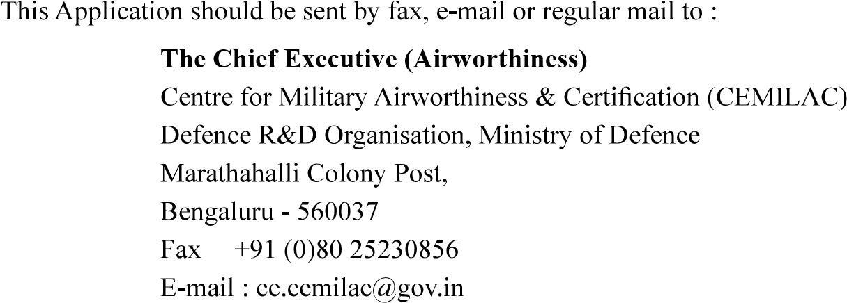

Acknowledgement of Receipt of Application
1. | Applicant’s Reference
2. | Address
2. | Address | PIN
3. | Air System Title

in due course of time.

