Version : 2.0 | Date: August 2023
Directorate General of Aeronautical Quality Assurance
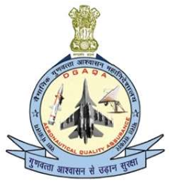
FORM - 1
AUTHORISED RELEASE NOTE
CERTIFICATE
No. |  |  |  |  |  |  |  |  | 3. Release Note No.
 |  | 9. Part |  |  |  |  |  |  | Inspector’s Inspection stamp
 |  |  |  |  |  |  |  | Accepted Till date
User / Installer Responsibilities
It is important to understand that the existence of the document alone does not automatically constitute authority to install the article on aircraft / aero-engine / System.

