Water Mist Aerator for Water Conservation

We use water in our day to day domestic activities, starting from washing, cooking, to cleaning, to drinking etc. these activities requires small amount of water, however more than 70% of water gives waste. Common ways in which people waste water at home are kitchen water wastage, leaky faucets etc. Atomization technique is used in large number of areas starting from fire fighting, agriculture, painting, fuel spray, etc. Use of atomization in domestic sector is becoming necessity to save the water. One of the most significant ways to control or stop the wastage of water is by converting water into water mist. Water mist and methods of delivery have many applications, spanning water evaporation, fuel combustion, humidifiers, snow making, powder metal fabrication, fire protection and suppression and for household purposes. Water mist may be narrowly defined as a liquid reduced or separated into atoms, but more broadly defined as a liquid broken into fine particles or fine drops.

The water mist aerator is a single fluid nozzle with low flow rate. By using this aerator the water consumption in the household shall be reduced. Water mist aerator has application in domestic sector for water conservation. The water mist aerator have been designed & developed according to the standard faucets available in India. The water mist aerator is fixed to the standard faucets/taps. The broad specification of the water mist aerator is mentioned below:-
- Mode of operation: Mist & Jet mode
- Material of Construction: SS 316L
- Flow rate: 300 – 1000 ml/min in mist mode
: ≥1000 ml/ min in Jet mode
- Working Pressure: 0.5-10 bar
- Droplet Size: 300 microns (VMD)
- Water Saving : Mist Mode 95% & Jet Mode 75% as compared to regular faucets.
- Maintenance free, retrofits into existing tap without disturbing aesthetics.
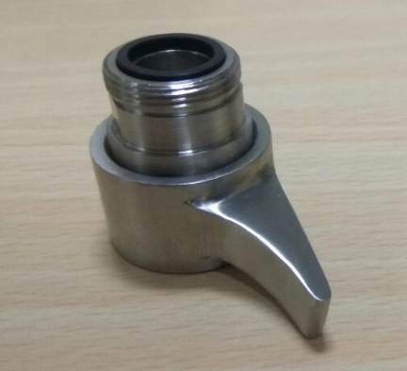

Water Mist Aerator Photograph

