Brief Write-up

Air breathing engines utilizing ramjet and scramjet are most eye-catching propulsion system for future transportation. The required characteristics of fuel for ramjet and scramjet is high energy with high density. The high density fuel is the fuel having density ~19% more as compared to Jet-A fuel. JP-10 is a high density fuel and chemically it is exo-tetrahydrodicyclopentadiene (THDPCD). Since, it is not commercially available, therefore, there is a need to develop high density fuel in the country.
The most important and primary strategic and weapons for Defence are air, sea and ground launched missiles system. The most important requirement of the missile fuel is to put more available energy in each unit of volume. Country like Japan, America, China etc. are manufacturing for their missile systems. In India, nobody is manufacturing Exo-THDPCD. In order to increase the self-reliance, it is necessary to develop bulk production facility for the synthesis of Exo-THDPCD.
The synthesis of Exo-THDCPD has been done at lab level through two step method. The first step involves the preparation of Endo-THDPCD by hydrogenation of Dicyclopentadiene (DCPD). The second step follows the isomerization of Endo-THDPCD using conc. H₂SO₄ (only 97-98 %). This reaction process is given below.
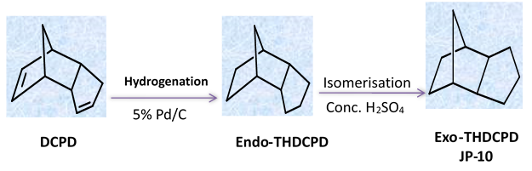
The yield of Exo-THDPCD (Purity 100 %) obtained in the process is 60% at 70-80 °C in 7-8 hrs.

