**Active Ear Defender**

Noise induced hearing loss in military and industrial environment is considered one of the most common occupational health hazards. Incidences of noise induced hearing loss are very high in different military and industrial environments.

**Designed to:**

* Protect from Noise Induced Hearing Loss
* Reduce noise over complete audible range
* Provide low and high frequency noise reduction
* Enable intelligibility of speech in noisy environment/workplace

**Noise Reduction:**

* NRR : 29dB
* Passive : up to 20dB
* Active : up to 17dB
* Active Noise Cancellation range : 50 - 630 Hz
* Total Noise attenuation range : 50 – 20,000 Hz

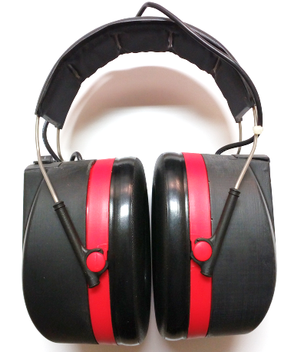

**Utility:**

* Safeguard Hearing
* Intact speech intelligibility

**Specifications:**

* Battery operated: 9V
* Weight: 387gms (w/o battery)
* Snug ear seals
* Relaxed headband pressure

**Applications:**

* Defence: Army workshops, Airforce Station Crew, Ships Engine Room
* Civil: Industrial Workshops