REUSABLE PCM HEAT PACK
Annexure G
Brief Description:
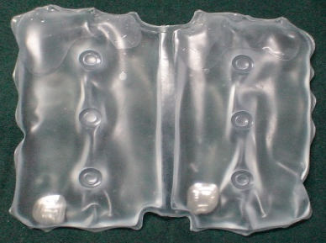
The extreme cold temperatures in high altitude regions takes a toll on the health of the soldiers. The PCM heat packs can be used to maintain higher skin temperature of human body at low temperature ambient conditions. PCM heat pack contains PCM to store heat and triggering device to release heat at the time of requirement.
WORKING PRINCIPLE : PCM heat pack works on the principle of storing heat in Metastable Super cooled Liquid Phase Change Material (MSCLPCM).
SALIENT FEATURES:
- Pack contains: A) MSLPCM to store heat
B) Mechanical triggering device to release heat
2. Heat remains entrapped in pack for longer duration even at subzero ambient conditions
3. Release of stored heat at the time of requirement and at constant temperature soothing to human body
4. PCM pack is charged by dipping it in hot water (70-80⁰C) for 15-20 minutes
5. Not toxic, non inflammable and non hazardous.
6. Reusable, Portable, reliable, odor free, instant heat source , where and when required
7. Easy to charge, use and maintain

AREA OF APPLICATION :
- To provide instant heat to personals deployed in extreme cold conditions
- For therapeutic use i.e. hyperthermia, backache-muscular, to provide first aid heat during cold injuries in field conditions at high altitude area etc .

CURRENT STATUS: Transfer of Technology is under process

