Electrochromic Window Technology
Annexure H
Electrochromic “Smart Windows” has tremendous potential towards providing a level of comforts to soldiers by restricting glares and unwanted solar transmission incoming through the windows of military vehicles, canopies of aircrafts and marine glazing.
Additionally, in a different perspective energy efficiency is nowadays something everyone has to think about. If there were a way to reduce the temperature inside without using air-condition, there would be a large energy gain. Electrochromic windows can be used in both hot and cold climate. This is because they can change their optical properties by the application of an electrical voltage. The structural design of Solid state Electrochromic Window represents a kind of parallel pate capacitor type of device structure through which one can electronically regulate the flow of solar transmission and heat. Adding a small voltage will cause the window to darken, and removing the voltage causes them to lighten again.
There are some obvious advantages to this feature, such as controlling the amount of daylight and heat flowing throw the window after what is wanted. As these windows can change properties after need, they have earned a nickname; smart windows. An application for hot climate would be to use a small photovoltaic cell that would be able to sense the amount of sunlight, darkening the window when the light is strong. This would lower the solar heating inside the room, lessening the need for air condition and therefore decreasing the energy needed to keep the room cool. It could also be possible to attach sensors to the window that can register whether there are people in the room or not, darken & bleach accordingly.
USP: The solid-state Electrochromic Window provides visual as well as thermal comfort to the occupant at the flick of a switch without putting load on electricity bill.
Current Status: The technology is in the process of commercialization and valuation of the technology has been carried out. It is valued at INR 1.6 Crores as license fee. M/S GSC Toughened Glass Co. a well known Glass processor company based at Greater Noida has shown his interest in our technology and given his consent.
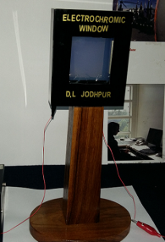
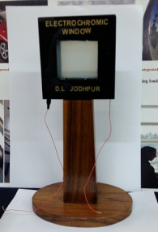

Bleached State Coloured State
ELECTROCHROMIC WINDOW

